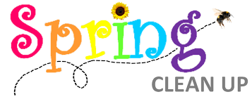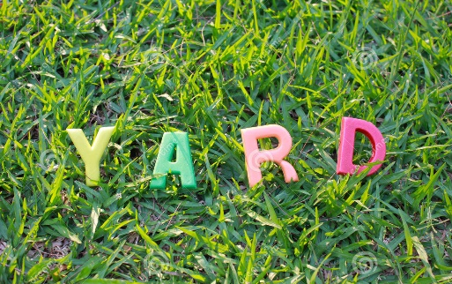

Spring yard pickup scheduled for April 29 – May 3rd on your scheduled trash pickup day

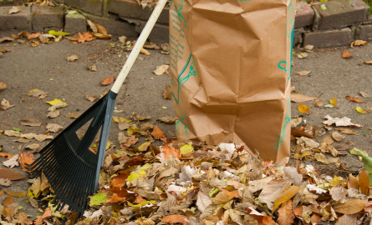

Hooksett spring yard cleanup will be the week of April 29th through May 3, 2024. Have brown recycle bags only (no plastic bags) of your yard cleanup on your scheduled trash day. This will be the only week that bags will be picked up curbside. No limbs, brush, or invasive plants will be accepted.
Please call (603) 669-5198 or email cdamon@hooksett.org with any questions.

